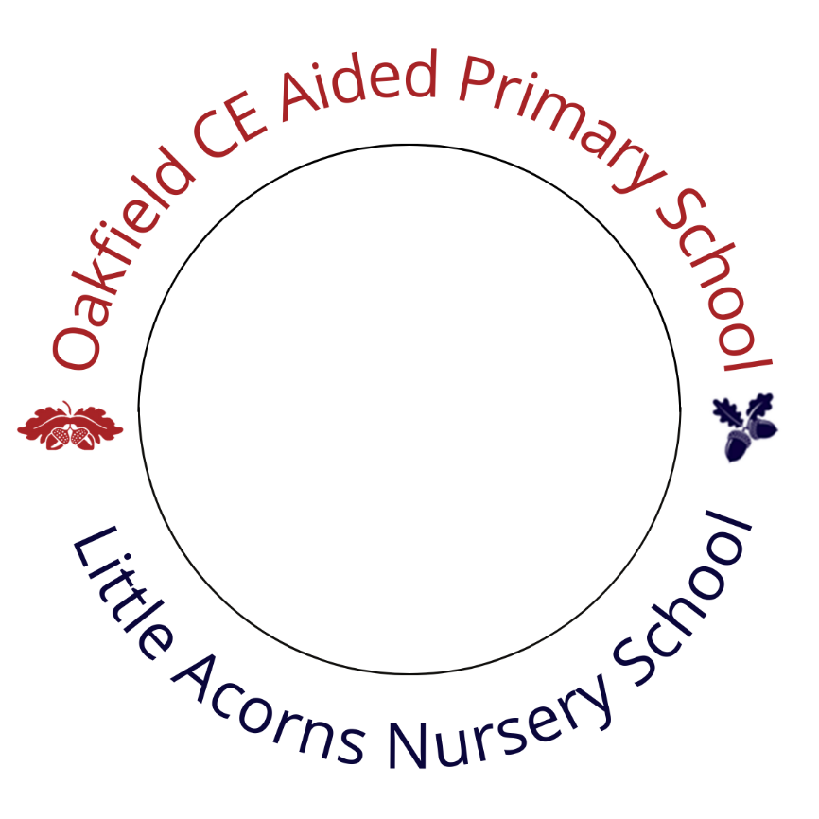
Creative Arts Policy

Date of Approval: | 2nd February 2026
Committee/FGB | FGB
Responsible: | Vikki Reader – Headteacher
Review Date: | February 2027

Signed: 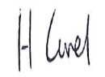 Chair of Governors

Signed: 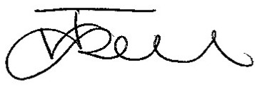 Headteacher

Date: 2nd February 2026

Revision No. | Date Policy Issued | Date Policy Revised: | Prepared By | Approved  By: | Comments
1 | 10/10/23 | 12/12/24 | SS |  | “No Change
2 | 22/01/25 | 26/01/26 | SS |  | Minor amendments to reflect current activities and storage of resources.

Oakfield CE Primary School
Creative Arts Policy
‘Art Makes Children Powerful’
A vibrant society does not exist from only scientists, engineers and financiers; life needs more diversity to make up a healthy and balanced whole. All of us have a little of everything, but more so of one thing, which we will eventually be making our living from. The Arts deserves as much, and equal, respect as the other disciplines. The Arts allows us to dream, wish, and experience together, individually, sometimes both at the same time. Art helps the economy; people will pay to see the ballet, the art and the drama. That is a good enough reason to ensure that there are future artists, and future audiences and fans.

This statement reflects our belief as a school about the importance of the Arts in all its varied forms and how this has a role in the development of children. The provision of the creative arts within the school is not simply a vehicle for wider opportunities but also a foundation for a lifelong source of pleasure and enjoyment and allowing the individual to understand and express opinions about their world.

What are the Creative Arts?
At Oakfield Primary School, we believe that the Arts are a fundamental part of the curriculum.

Aims and Objectives
The overall objective is to ensure that children are getting their entitlement to a curriculum rich in high-quality arts experiences. All children should develop respect, understanding and appreciation of their own and others cultural and linguistic heritage through the celebration of the Arts. We will provide opportunities, both in and out of school to develop self-esteem, confidence and maturity through participation in the Arts.

At Oakfield Primary School we strive to:

- Provide all pupils’ opportunities to explore values, attitudes, meanings and feelings and acquire new skills

- Stimulate children’s imagination and creative minds

- Recognise, understand and value the artistic and cultural heritage of their own and others environment

- Gain satisfaction and personal enrichment offered by participating in a range of creative arts

Organisation and Planning
The planning and mapping of the skills across the year groups helps staff to identify cross-curricular links with other areas of the curriculum. The arts are generally planned within the key stages and identified on the medium and long term plans.

Equal Opportunities
We recognise that children within our school have an entitlement to all aspects of the Creative Arts offered within the curriculum, regardless of race, gender or disability. Pupils with SEN are encouraged and supported where appropriate to be fully integrated into all creative arts based activities.

Resources
Resources are kept in the ART room for all to access. Music based resources are also available in the Studio. Drama and role play are used in the classrooms and the Studio by teachers and reception and KS1 areas have their own role play areas. Cameras, Ipads and Laptops are available for all classes to utilise.

Extra Curricular Activities
We offer a range of arts clubs that can be accessed by pupils. A number of arts after school clubs are provided including dance, art, drama/singing, crafts, sewing, and learning to play the guitar.

Governor Link
Governor links are vital to monitor activities and initiatives and support at school events.

Partnerships
We believe the value of partnerships with arts organisations raises awareness of opportunities in the arts. We are looking to create new links through our previous participation in the Arts Mark and continuing CPD.

